Requirements

By making a game, you will gain experience in JavaScript as well as DOM handling and some CSS.

**The Task**

This assessment task requires you to make an interactive game. Please see the accompanying video for an example walk-through. Some of the skills in this assessment task are demonstrated in the Example DOM Project, and the code for that project has been released in the system. You are recommended to look at that project and understand it prior to starting this assessment task.

When the game starts, five faces are shown on the left and four are shown on the right. This is illustrated below.

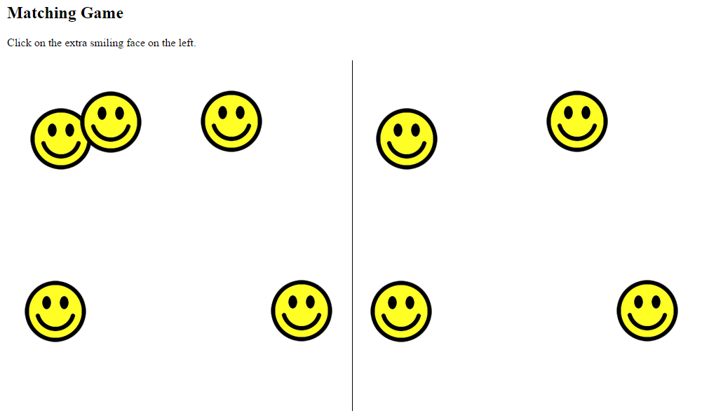

The left and right sides are identical, except for one thing: the left side has one extra face. The user needs to click on that extra face. If anything except the correct face is clicked, a message is displayed saying that the game is over. If the correct face is clicked, all the currently displayed faces are deleted and a new set of faces is shown at random positions. Each time a new set of faces is shown there will be 5 more faces than before, on both the left and the right sides. There will always be one extra face shown on the left.

For example, let’s imagine you are playing the game shown in the previous figure. After clicking on the extra face (at the top) all the faces disappear and the following new set of faces are shown. As you can see, on both sides 5 more faces than before are shown.

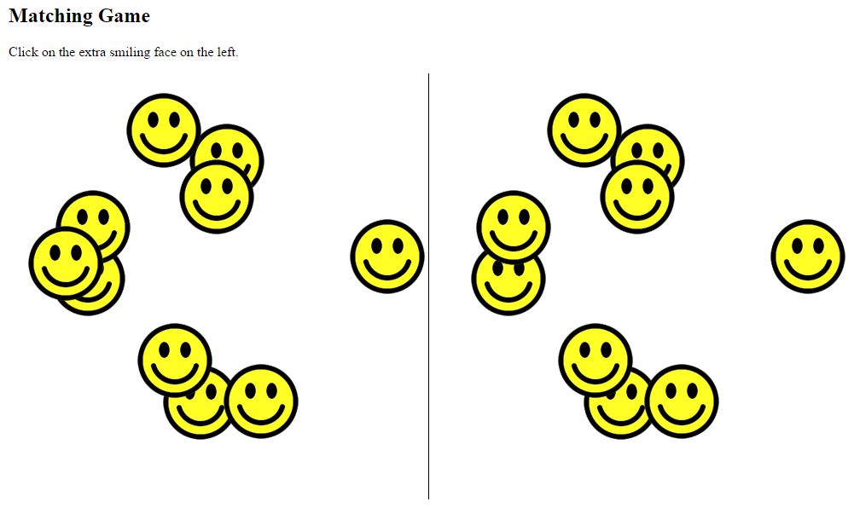

After playing the game by correctly clicking on the extra face many times, a lot of faces will be shown. This is illustrated below.

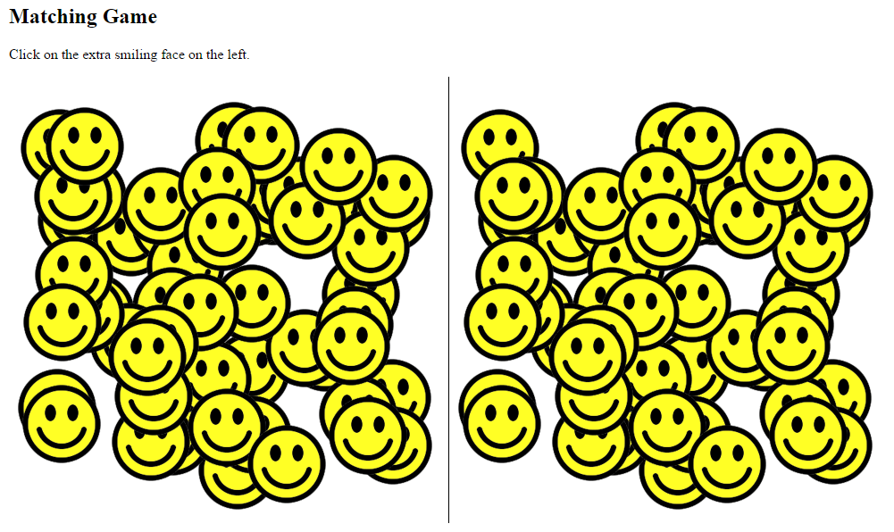

**Technical Overview**

The text instructions are handled by simple HTML.

Two *div* elements are included in the *body*, like this:

    <div id="leftSide"></div>

    <div id="rightSide"></div>

The first div is used to store all the faces shown on the left side. The second div is used to store all the faces shown on the right side.

The line shown in the middle of the web page is created by applying a style rule which tells the browser to show a border line for only the left side of the *rightSide* div.

The faces are dynamically created by JavaScript. First, all the faces are generated on the left side, under the div with id ‘leftSide’. Then*cloneNode(true)* is used to clone all the faces to the div with id ‘rightSide’, so there is an exact copy. The last child in this new branch is then deleted, so that when the user looks at the screen there is one extra face on the left side compared to the right side.

The event handling is also applied by JavaScript. It will help you to understand the *Adding Events Using JavaScript*lesson and accompanying examples in the course. There are two event handlers:

1. One *onclick* event handler is applied to the extra face on the left side which the user needs to click on. When the event is triggered a variable containing the number of faces to be generated is increased by 5, and then the process of generating and displaying the faces begins again.
2. The second *onclick* event handler is applied to the body. If this function is triggered, it means the player has failed to select the correct face and the game is over. When this event is triggered an appropriate message is shown and the two event handler functions are removed.

The smiling face is a simple image called *smile.png*, which is given to you.

<http://home.cse.ust.hk/~rossiter/mooc/matching_game/smile.png>

**Which Browser to Use**

This project was developed using the Chrome browser. The project has been checked on the latest versions of Firefox, Internet Explorer, Safari, and Opera and works well in all of them. However, to avoid any potential trouble with inconsistencies between browsers it may be wise for you to use Chrome.

**What to Submit**

You can only submit one single HTML file, which includes the JavaScript code within the file. That means there are no links to external JavaScript files or CSS files in this assessment task. The image file *smile.png* is given to you on the web site.

**What to Submit**

There are 4 parts of this assessment. You need to submit 1 file for each part. For each part you can only submit one single HTML file, which (for parts 2, 3 and 4) includes JavaScript code within it. That means there are no links to external JavaScript files or CSS files in this assessment task.

Here are the more specific requirements and further information for both parts.

Overview of the Parts

Part 1 – developing the web page content without JavaScript

Part 2 – generating the left side images

Part 3 – handling the right side

Part 4 – finishing the game